The neurophysiology of phonemic contrasts perception by multilingual listeners in diverse learning settings
Hanna Kędzierska, Karolina Rataj, Anna Balas, Chloe Castle, Zuzanna Cal,
Magdalena Wrembel

Non-native phonemic perception is considered a vital component of successful language learning and has become a focus of mounting scientific research. Several neurophysiological studies have documented reduced phonemic discrimination mechanisms in the second language (L2) when compared with the first language (L1) (Jakoby et al., 2011; Liang & Chen, 2022; Song & Iverson, 2018). In the current study we wished to contribute to an ongoing scientific debate on multiple foreign languages interacting in the mind of the same speaker. Specifically, we focused on the mismatch negativity (MMN) component which is assumed to reflect ease of phonemic discrimination (Näätänen et al., 1997). The research aimed at answering the following research questions:
- Will any significant differences in the terms of the MMN effect emerge in L3/Ln as opposed to L1 and L2?
- Will there be any significant differences between formal and naturalistic learners?
With respect to the first question, we predicted the MMN to be stronger in native when compared with non-native speech (Jakoby et al., 2011; Liang & Chen, 2022; Näätänen et al., 1997; Song & Iverson, 2018). The scale of the MMN effect in L2 when compared with L3/Ln was, however, impossible to predict due to the lack of previous studies which would focus on such a comparison. With respect to the second question, we expected the MMN response to be enhanced in naturalistic when compared with instructed language learners (Peltola et al., 2003; Winkler et al., 1999).
We used event related brain potentials (ERPs) combined with the oddball paradigm to investigate vowel contrast perception among L1 Polish-L2 English-L3/Ln Norwegian speakers. The following vowel contrasts were used for each language: /ɨ/-/ɛ/ for Polish, /ɪ/-/ʊ/ for English and /i/-/ʏ/ for Norwegian. Speech sounds were played via earphones while participants watched a silent movie. While 23 of them were students of Norwegian philology living in Poznań, Poland, 21 were Polish migrants living in Tromsø, Norway. In the former (i.e., instructed) group, statistically significant differences were observed for all three languages, with the strongest MMN effect in Polish, weaker in English, and weakest in Norwegian (see Figure 1). Contrastingly, in the latter (i.e., naturalistic) group, the experiment demonstrated no significant differences between Polish and English and a significantly weaker effect in Norwegian.
Overall, our study provides the first evidence that L2 or Ln foreign language status modulates auditory language processing. Moreover, the results indicate significant differences between naturalistic and instructed language learners. This clearly suggests that the overall multilingual experience (affected by living in different settings) direct implications for speech perception mechanisms.

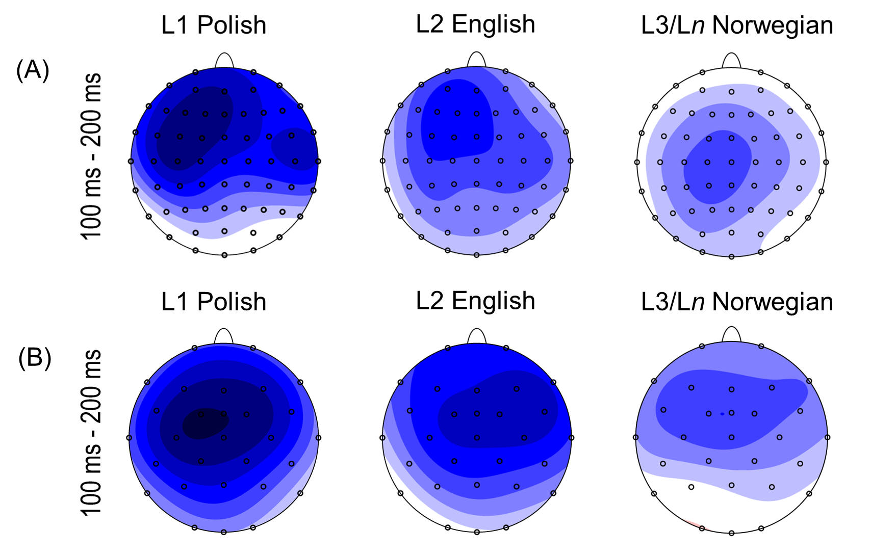
Figure 1: ERP effects elicited in instructed (A) and naturalistic (B) learners in three investigated languages

References:
Jakoby, H., Goldstein, A., & Faust, M. (2011). Electrophysiological correlates of speech perception mechanisms and individual differences in second language attainment. Psychophysiology, 48, 1516–1530. https://doi.org/10.1111/j.1469-8986.2011.01227.x
Liang, L., & Chen, B. (2022). The non-native phonetic perception mechanism utilized by bilinguals with different L2 proficiency levels. International Journal of Bilingualism, 26(3), 368–386. https://doi.org/10.1177/13670069211058275
Näätänen, R., Lehtokoski, A., Lennes, M., Cheour, M., Houtilainen, M., Iivonen, A., Vainio, M., Alku, P., Ilmoniemi, R. J., Luuk, A., Allik, J., Sinkkonnen, J., & Alho, K. (1997). Language-specific Phoneme Representations Revealed by Electric and Magnetic Brain Responses. Nature, 385, 432-434.
Peltola, M. S., Kujala, T., Toumainen, J., Ek, M., Aaltonen, O., & Näätänen, R. (2003). Native and Foreign Vowel Discrimination as Indexed by the Mismatch Negativity (MMN) Response. Neuroscience Letters, 352, 25–28.
Song, J., & Iverson, P. (2018). Listening effort during speech perception enhances auditory and lexical processing for non-native listeners and accents. Cognition, 179, 163–170. https://doi.org/10.1016/j.cognition.2018.06.001
Winkler, I., Kujala, T., Tiitinen, H., Sivonen, P., Alku, P., Lehtokoski, A., Czigler, I., Csépe, V., Ilmoniemi, R. J., & Näätänen, R. (1999). Brain Responses Reveal the Learning of Foreign Language Phonemes. Psychophysiology, 36, 638–642.

